Programming@FMS
Student Edition
Programming – unit 4

Objectives

You shall understand a simulation as a way of searching a solution for a problem.

You will analyse and test the provided example of the simulation of a lawn mowing robot.

You will supplement the simulation example with an algorithm you will develop on your own.

You shall understand the block concept for a clear soutline of programs.

Introduction

Programming can be understood as a methodical procedure for finding the solution to a problem and formulating it in a language that computers can interpret.

In practice, however, we also encounter problems for which no suitable solutions are known yet. In such cases, simulations can help to find solutions (or at least approaches to solutions).

A computer simulation is a program that models a system (e.g. the streets in residential area with high traffic volume) and shows (often with a visualisation) how the simulated system behaves under different conditions (e.g. if speed limit 30 was introduced, or if some streets were converted into one-way streets). Computer simulations are useful, for example, when experiments with the real system of interest are too costly, too dangerous or even impossible. And even when experiments are possible, comparison with simulations often helps to better understand the behaviour of the individual components of a system.

In this lesson, you will analyse the example of a simulation program for a lawnmowing robot. You will supplement the program with a self-developed algorithm, which causes the robotic lawnmower to "return" to its box at the end of the simulation.

Getting familiar with the example program

⇨ Start the program "RobotLawnMowerSimulation-Template". Please find it on the Scratch platform: https://scratch.mit.edu/projects/878189075/

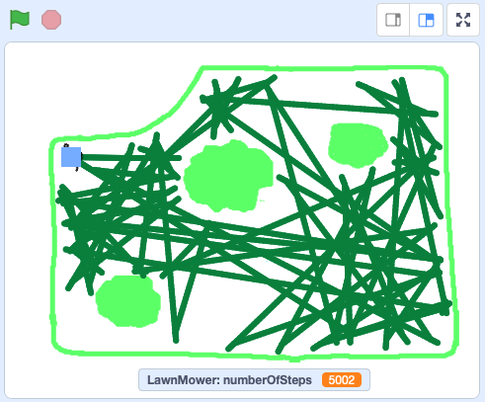Fig. 1: Simulation of a robotic lawnmower
The program simulates a robotic lawnmower on a plot of land with shrubs. When the lawnmower touches an obstacle (a shrub, the edge of the plot), it backs up a bit and then rotates through a random angle between 15 and 30 degrees. Then the lawnmower continues straight ahead until it touches an another obstacle.

⇨ Restart the program several times. Make a screenshot at the end of each simulation. Compare the paths of the lawnmower.

The robot is controlled by an algorithm.

An algorithm is a sequence of instructions which can be used to solve a problem step by step.

An algorithm is called to be robust if it solves the problem reliably even if the execution conditions change.

An algorithm can be programmed in such a way that its repeated execution yields always the same result (given the same inputs). The result is then predictable. Such algorithms are therefore generally called determined.

In contrast, the algorithm of the simulated robotic lawnmower is not determined. In every simulation, the paths of the lawnmower are different.

Is the robotic lawnmower's algorithm at least robust, i.e. does it still work reliably when there are additional obstacles on the plot?

⇨ Place a «house» (a new object) somewhere on the plot of land. Adjust the initialisation of the object „house" so that it is visible when the program is started.

⇨ Adjust the mowing algorithm so that the lawnmower also recognises the house as an obstacle.

⇨ Now restart the program several times and compare the paths of the lawnmower.

The block concept for the outline of programs

The script of the simulation program is very simple.

The script comprises two blocks: "initialisation" and "mowing". The individual instructions for the initialisation and the control of the robotic lawnmower are defined as separate blocks. The division into blocks makes the program clearly laid out.
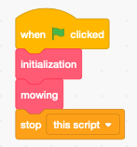Fig. 2: Script of the simulation program

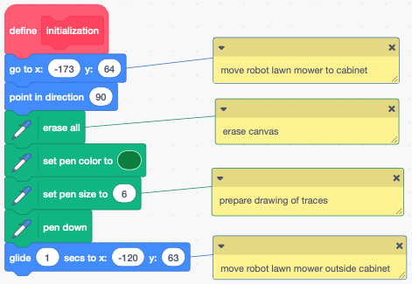Fig. 3: Definition of the block "initialisation"
You shall implement the subsequent extension of the simulation algorithm by means of a block.

Extending the algorithm to control the robotic lawnmower

So far, the lawnmower stops somewhere after the number of specified steps. However, the lawnmower should drive back into the box at the end.

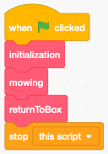Fig. 4: The extended simulation program
⇨ Design an algorithm that leads the lawnmower back to the box. For this purpose, define the block "returnToBox".

Test the algorithm by running the program a couple of times. If necessary, refine your block.

Reflection

Discuss the usefulness of the simulation from the point of view …

- of a company offering robotic mowers and
- of a person who wants to buy a robotic mower.

Probably in none of the simulations you have done the "lawn" has been completely "mowed". Do we have to accept that even with computers, completely satisfactory solutions cannot be found for all problems? Do we have to give up warranties for programs?

Are you aware of other areas of application where simulations are useful or even necessary?

Discuss possible risks that could arise when we transfer simulation results to reality.

